DCF 160122 Dan 8: 1-14 Vision of a Ram and a Goat – Contending with Complacency
Dan 8:1 In the third year of the reign of King Belshazzar a vision appeared to me—to me, Daniel—after the one that appeared to me the first time. ² I saw in the vision, and it so happened while I was looking, that I was in Shushan, the citadel, which is in the province of Elam; and I saw in the vision that I was by the River Ulai.
What use is this vision recorded for us, who live 2500 years after Daniel? Firstly, so that we can see the precision of God’s hand in history. Daniel had already had the vision recorded in Ch 7, of the 4 beasts. This must have sat like a rock in his memory, and 2 years later, he has this next vision. Secondly, so that we can understand that empires and nations who refuse to repent and turn to God will fall. Judgement comes to nations that turn against God. Australia must repent.
We have to see that God has our life planned in impeccable detail. In Maths we deal so much with probability and chance. Randomness is taught, and we ignore the hand of God. But God invented Maths, and it becomes so much more amazing, when we see His hand, at times when we least expect it. I know just a few of the many times when God has saved my life, and stopped me from doing something stupid.
In the 3rd year of King Belshazzar, Babylon was securely in power. There would have been a complacency, just like we have in Perth. They may have been aware of unrest in other parts of the world, just like us, but it did not really matter. Daniel was in Shushan, on business for the king. In the middle of mundane everyday affairs, God gives Daniel a vision.
The experience was obviously something very real and troubling – not just a dream he could dismiss. Dan 8:27 ²⁷ And I, Daniel, fainted and was sick for days; afterward I arose and went about the king’s business. I was astonished by the vision, but no one understood it.
Dan 8:3 ³ Then I lifted my eyes and saw, and there, standing beside the river, was a ram which had two horns, and the two horns were high; but one was higher than the other, and the higher one came up last. ⁴ I saw the ram pushing westward, northward, and southward, so that no animal could withstand him; nor was there any that could deliver from his hand, but he did according to his will and became great.
The 2 horns represented the Medes first, and the stronger Persians who came later. The Medo-Persian Empire conquered the Scythians in the north, the Greeks in the West and the Egyptians in the South. The ram represented the Medes and the Persians who were a threat to the Babylonians. Rather like China and Australia, today. Their culture was soaked in sexual immorality and idolatry.
“Ammianus Marcellinus, a fourth century historian, states that the Persian ruler bore the head of a ram as he stood at the head of his army.” (Wood) “The ram was the national emblem of Persia, a ram being stamped on Persian coins as well as on the headdress of Persian emperors.” (Strauss)
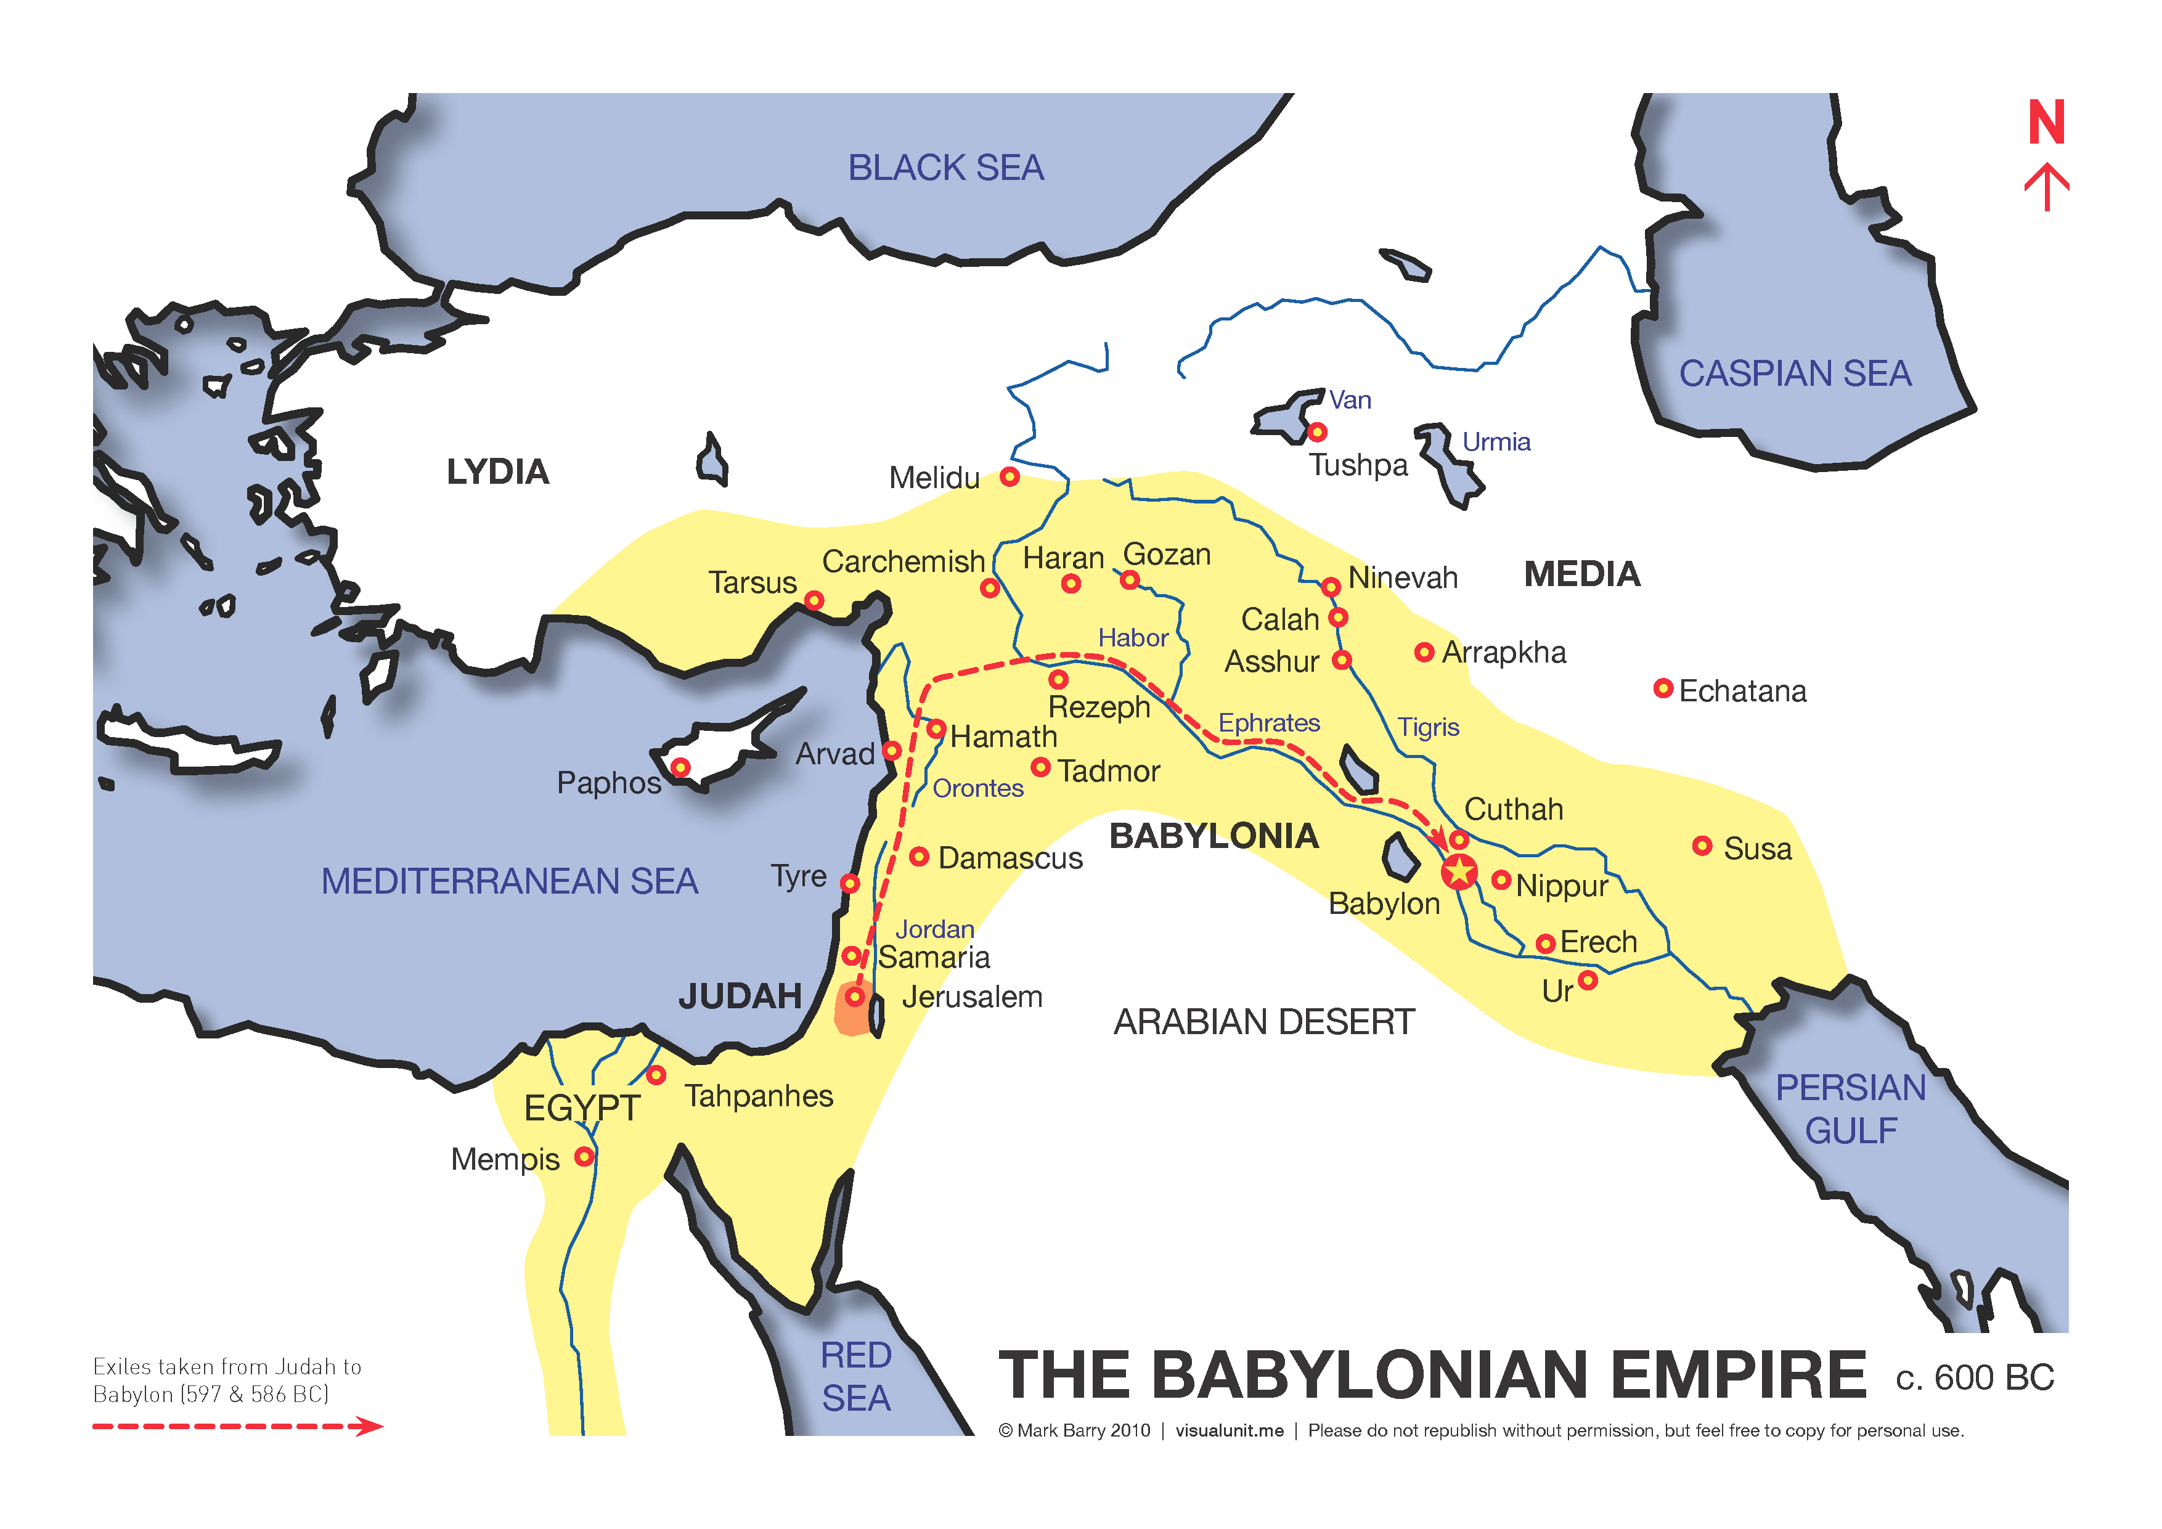
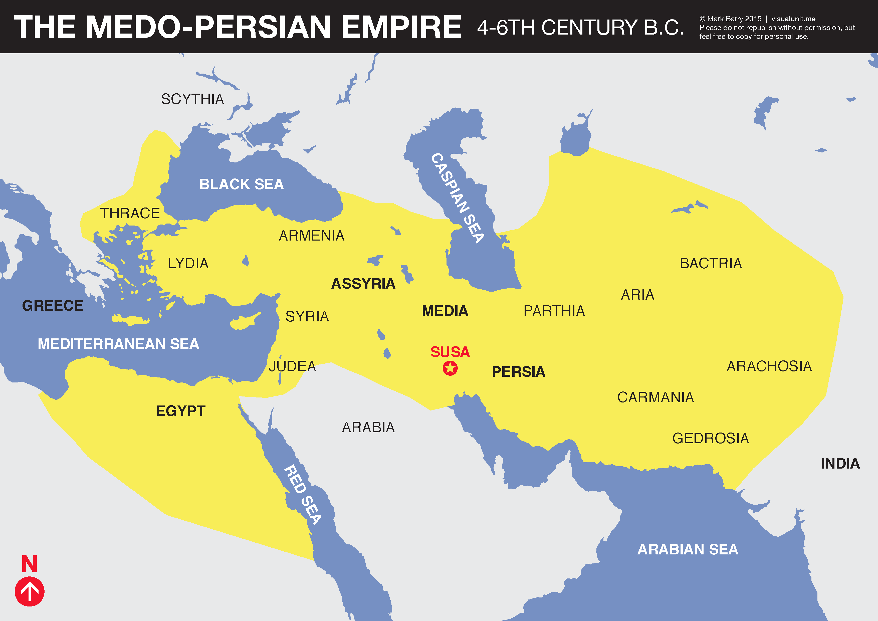

Dan 8:5 ⁵ And as I was considering, suddenly a male goat came from the west, across the surface of the whole earth, without touching the ground; and the goat had a notable horn between his eyes. ⁶ Then he came to the ram that had two horns, which I had seen standing beside the river, and ran at him with furious power. ⁷ And I saw him confronting the ram; he was moved with rage against him, attacked the ram, and broke his two horns. There was no power in the ram to withstand him, but he cast him down to the ground and trampled him; and there was no one that could deliver the ram from his hand.
Even 200 years before Daniel, historians had observed that the Greeks were called the ‘goat people’. The Greek empire conquered nations very quickly. Its most famous ruler was Alexander the Great. The battle between the Greeks and the Persians was ferocious and quick. Empires become very arrogant with their power. This arrogance leads them away from God, and judgement was inevitable.
In Rev 18, the new Babylon falls very quickly. Rev 18:10 ⁹ “The kings of the earth who committed fornication and lived luxuriously with her will weep and lament for her, when they see the smoke of her burning, ¹⁰ standing at a distance for fear of her torment, saying, ‘Alas, alas, that great city Babylon, that mighty city! For in one hour your judgment has come.’
We saw it was a surprise to Belshazzar who was desecrating the gold vessels taken from God’s temple, when he was killed by Darius that night. Dan 5:30 ³⁰ That very night Belshazzar, king of the Chaldeans, was slain. ³¹ And Darius the Mede received the kingdom, being about sixty-two years old.
We have been warned that the western world, which is the harlot or fake bride, will fall quickly. Finances and safety will crumble. History warns us to be ready.
Dan 8:8 ⁸ Therefore the male goat grew very great; but when he became strong, the large horn was broken, and in place of it four notable ones came up toward the four winds of heaven.
Alexander’s reign ended quickly. He died just before he turned 33. He became the ‘great king’ of Persia at the age of 25. Over the next 8 years he led his army over 17,000 km (5.8km/day) and founded 70 cities. His empire formed a huge network for trade and commerce. He believed he was indestructible, but died of a fever in June 323 BC. his empire was divided into 4, by his 4 leading generals. Cassander taking Greece, Lysimachus taking Asia Minor, Seleucus taking Syria and Israel, and Ptolemy taking Egypt.
But this was so far in the future for Daniel – what did it mean for him? Primarily it would have anchored in him, the 2 huge truths. God has control of history, and secondly, unless a nation repents – judgement will come. Now, narrow down that thought to you and me.
Eph 2:10 ⁴ But God, who is rich in mercy, because of His great love with which He loved us, ⁵ even when we were dead in trespasses, made us alive together with Christ (by grace you have been saved), ⁶ and raised us up together, and made us sit together in the heavenly places in Christ Jesus, ⁷ that in the ages to come He might show the exceeding riches of His grace in His kindness toward us in Christ Jesus. ⁸ For by grace you have been saved through faith, and that not of yourselves; it is the gift of God, ⁹ not of works, lest anyone should boast. ¹⁰ For we are His workmanship, created in Christ Jesus for good works, which God prepared beforehand that we should walk in them.
Jer 1:5 Before I formed you in the womb I knew you; before you were born I sanctified you…
God is outside time, and has so planned our lives that we can rest in His love and grace. Even when we were dead in trespasses, He made us alive. He gives us fellowship, so we can share our love, and we will sit together in heavenly places. We may well count our riches in terms of dollars, in this life, but one day, riches will be measured by the grace of God. So, you are not a random, expendable, bizarre event. We were planned in incredible detail. We were crafted as His workmanship. We have good works scheduled for us to fulfil to bring Him glory. Pray for an alertness to speak out and do what God has planned for you.
It was through Alexander that the Greek language became the common language of the civilized world. This was the language of the New Testament and the early church. Alexander conquered for power, but God used his empire for us.
Dan 8:9 ⁹ And out of one of them came a little horn which grew exceedingly great toward the south, toward the east, and toward the Glorious Land. ¹⁰ And it grew up to the host of heaven; and it cast down some of the host and some of the stars to the ground, and trampled them.
The Glorious land referred to Israel. Abraham had travelled far to get there. Moses had led the children of Israel for 40 years, through the desert, to return there. Jesus, the Son of God, would be born and crucified there. It is hated by the enemies of God. Psalm 83:4 ⁴ They have said, Come, and let us wipe them out as a nation; let the name of Israel be in remembrance no more. But it will be the centre of government when Jesus returns.
The first little horn was Antiochus Epiphanes who was a forerunner to the Antichrist. Indeed 1 John 2:18 warns us that many antichrists will come, and John warns us that these will have phony Christian links. ¹⁸ Little children, it is the last hour; and as you have heard that the Antichrist is coming, even now many antichrists have come, by which we know that it is the last hour. ¹⁹ They went out from us, but they were not of us; for if they had been of us, they would have continued with us; but they went out that they might be made manifest, that none of them were of us.
In politics, it is profitable to gain the Christian vote – like Biden, who goes to church and supports the sacrifice of babies. Or Archbishop Desmond Tutu who also supported abortion and euthanasia, and is quoted as saying: “I would refuse to go to a homophobic heaven. No, I would say, 'Sorry, I would much rather go to the other place.'” It is not the place that matters – it is the presence of God.
If our worship is not backed up by our life in the week, God says in Mal 1:10 “Who is there even among you who would shut the doors, so that you would not kindle fire on My altar in vain? I have no pleasure in you,” Says the Lord of hosts, “Nor will I accept an offering from your hands.
The fall of Israel is a picture of the fall of the Western world. Just going through Ezekiel, we read 3:7 The house of Israel will not listen. 5:11 … you have defiled My sanctuary with all your detestable things and with all your abomination. 6:9 God says: I was crushed by their adulterous heart. 8:17 … you have filled the land with violence. 13:19 … keeping people alive who should not live … 13:22 … you have strengthened the hands of the wicked….
Antiochus Epiphanes was a brutal conqueror who desecrated the things of God. But the people of Israel had already desecrated the holy things of God. In Australia we have done just that. When the church does nothing and says nothing against abortion, 3 terrible things happen. 1- an innocent baby is killed. 2 – Satan paralyses the mother, father and people involved with guilt, so that they either confess their sin to Jesus, or they get angry when their guilt is exposed. 3 – we release the spirit of murder and violence into our land, so that lives, especially innocent lives, no longer matter. We need to see that the spiritual results are far bigger than the flesh side. Babies are killed – yes. But people end up spending eternity in hell as a consequence. Repentance is never comfortable. Should I shut up and not go on about it? No. Jesus came and died to save people from hell. We have to do everything we can, to boldly proclaim the gospel. The practice of child sacrifice was and still is common in many countries. It had polluted the land.
Psalm 106:35 ⁵ But they mingled with the Gentiles And learned their works; ³⁶ They served their idols, which became a snare to them. ³⁷ They even sacrificed their sons and their daughters to demons, ³⁸and shed innocent blood, the blood of their sons and daughters, whom they sacrificed to the idols of Canaan; and the land was polluted with blood. ³⁹ Thus they were defiled by their own works, and played the harlot by their own deeds. ⁴⁰ Therefore the wrath of the Lord was kindled against His people, so that He abhorred His own inheritance. ⁴¹ And He gave them into the hand of the Gentiles, and those who hated them ruled over them. ⁴² Their enemies also oppressed them, and they were brought into subjection under their hand. ⁴³ Many times He delivered them; but they rebelled in their counsel, and were brought low for their iniquity.
When the church stays silent about the LGBTQ battle, we desecrate marriage. We desecrate the distinctive roles of fathers and mothers, husbands and wives, children and parents. I am a father and a husband. So, I need to be everything God the Father and Jesus the bridegroom are to me, to my wife and children.
Our nation has said OK to porn and violence as entertainment. We have forsaken fellowship and worship. We have worshipped the gods of sport. We revere the demonic spirits of the land in smoking ceremonies. We have ignored the homeless. Domestic violence has increased. We have accepted and not condemned the use of Jesus Christ as a swear word. We have protected sharks and animals more than people. We publish horoscopes instead of Bible verses. The 10th commandment forbids covetousness. TV is full of adverts, so we can want something that we do not need. Materialism, which puts clothes and cars and houses before God is idolatry.
We and the western world are in a time of judgement. We have closed our eyes to the abominations in Australia and we have not repented. Is 5:20 ²⁰ Woe to those who call evil good and good evil, who put darkness for light and light for darkness, who put bitter for sweet and sweet for bitter!
Dan 8:11 ¹¹ He even exalted himself as high as the Prince of the host; and by him the daily sacrifices were taken away, and the place of His sanctuary was cast down. ¹² Because of transgression, an army was given over to the horn to oppose the daily sacrifices; and he cast truth down to the ground. He did all this and prospered.
In Australia, the anti-Christian lobby, seek to remove prayers, Bible readings, church services, Biblical inscriptions, from public spaces, parliament, schools, hospitals. Trans people have library sessions with children. Sydney is being judged for their gay-pride Mardi-gras – but no one sees the judgement. Marin Iles was nearly locked out of Albany, speaking for God.
Dan 8:13 ¹³ Then I heard a holy one speaking; and another holy one said to that certain one who was speaking, “How long will the vision be, concerning the daily sacrifices and the transgression of desolation, the giving of both the sanctuary and the host to be trampled underfoot?”
¹⁴ And he said to me, “For two thousand three hundred days; then the sanctuary shall be cleansed.”
Historians tell us that the date when the temple was cleansed was December 25, 165 B.C. If we count back 2,300 days from then, we come to the year when Antiochus Epiphanes began his persecution in earnest (171 B.C.). Isn’t it amazing that a prophecy written 350 years before Antiochus Epiphanes is fulfilled with such precision. Our God is not bound by time as we are. He created time.
So, the same lesson is repeated. I asked God, do I preach the same message: The Bride must get ready? He said: Yes. How many times? Till they hear it, because if a nation does not repent – judgement will come.

Final Hymn: Search me O God and know my heart today.

Homework
i. Antiochus Epiphanes exerted his dominion toward the south, toward the east, and toward the land of Israel.
ii. Antiochus Epiphanes murdered other rulers and persecuted the people of Israel (cast down some of the host and some of the stars to the ground, and trampled them).
iii. Antiochus Epiphanes blasphemed God and commanded idolatrous worship directed towards himself (exalted himself as high as the Prince of the host).
iv. Antiochus Epiphanes put a stop to temple sacrifices in Jerusalem (by him the daily sacrifices were taken away).
v. Antiochus Epiphanes desecrated the temple (the place of His sanctuary was cast down).
vi. Antiochus Epiphanes opposed God and seemed to prosper (he cast truth down to the ground. He did all this and prospered).

And trampled them: Antiochus was an infamous persecutor of the Jewish people. He wanted them to submit to Greek culture and customs and was more than willing to use murder and violence to compel them.
i. Antiochus’s suppression of the Jews came to a head in December of 168 B.C. when he returned in defeat from Alexandria. He ordered his generals to seize Jerusalem on a Sabbath. There he set up an idol of Zeus and desecrated the altar by an offering of swine and sprinkling the pig’s juices in the sanctuary. Sacrifice stopped because the temple was desecrated.
ii. 1 Maccabees 1:29-32 and 1:52-61 describe how Antiochus persecuted the Jews. 1 Maccabees 1:41-50 describes his blasphemies. By some estimates he was responsible for the murder of more than 100,000 Jews.
· And after two years fully expired the king sent his chief collector of tribute unto the cities of Juda, who came unto Jerusalem with a great multitude, and spake peaceable words unto them, but all was deceit: for when they had given him credence, he fell suddenly upon the city, and smote it very sore, and destroyed much people of Israel. And when he had taken the spoils of the city, he set it on fire, and pulled down the houses and walls thereof on every side. But the women and children took they captive, and possessed the cattle. (1 Maccabees 1:29-32)
· Then many of the people were gathered unto them, to wit every one that forsook the law; and so they committed evils in the land; and drove the Israelites into secret places, even wheresoever they could flee for succour. Now the fifteenth day of the month Casleu, in the hundred forty and fifth year, they set up the abomination of desolation upon the altar, and builded idol altars throughout the cities of Juda on every side; and burnt incense at the doors of their houses, and in the streets. And when they had torn in pieces the books of the law which they found, they burnt them with fire. And whosoever was found with any book of the testament, or if any committed to the law, the king?s commandment was, that they should put him to death. Thus did they by their authority unto the Israelites every month, to as many as were found in the cities. Now the five and twentieth day of the month they did sacrifice upon the idol altar, which was upon the altar of God. At which time according to the commandment they put to death certain women, that had caused their children to be circumcised. And they hanged the infants about their necks, and rifled their houses, and slew them that had circumcised them. (1 Maccabees 1:52-61)
· Moreover king Antiochus wrote to his whole kingdom, that all should be one people, and every one should leave his laws: so all the heathen agreed according to the commandment of the king. Yea, many also of the Israelites consented to his religion, and sacrificed unto idols, and profaned the sabbath. For the king had sent letters by messengers unto Jerusalem and the cities of Juda that they should follow the strange laws of the land, and forbid burnt offerings, and sacrifice, and drink offerings, in the temple; and that they should profane the sabbaths and festival days, and pollute the sanctuary and holy people: set up altars, and groves, and chapels of idols, and sacrifice swine?s flesh, and unclean beasts: That they should also leave their children uncircumcised, and make their souls abominable with all manner of uncleanness and profanation, to the end they might forget the law, and change all the ordinances. And whosoever would not do according to the commandment of the king, he said, he should die. (1 Maccabees 1:41-50)

The first attack of Antiochus against the Jews of this time was to settle a rivalry for the office of high priest. A pious high priest, Onias III, was removed from office and was replaced with his brother Jason because Jason bribed Antiochus. Then in 172 B.C. another brother (Menelaus) gave Antiochus an even bigger bribe and replaced Jason. A year later Menelaus started selling many of the temple’s gold utensils to raise money to pay off the bribe. Onias III rebuked him, and Menelaus had him murdered. Meanwhile, Jason gathered armies and fought against Menelaus to regain the office of High Priest. Antiochus Epiphanes came in to Jerusalem in 171 B.C. to defend the man who paid him a bigger bribe to be the High Priest.
ii. “This was the reason why God set over them such a breathing devil, as was Antiochus, for a punishment of their open impiety and formal apostasy.” (Trapp)

Temple Prostitution in Babylon.
The foulest Babylonian custom is that which compels every woman of the land to sit in the temple of Aphrodite and have intercourse with some stranger once in her life. Many women who are rich and proud and disdain to mingle with the rest, drive to the temple in covered carriages drawn by teams, and stand there with a great retinue of attendants. But most sit down in the sacred plot of Aphrodite, with crowns of cord on their heads; there is a great multitude of women coming and going; passages marked by lines run every way through the crowd, by which the men pass and make their choice. Once a woman has taken her place there, she does not go away to her home before some stranger has cast money into her lap, and had intercourse with her outside the temple; but while he casts the money, he must say, “I invite you in the name of Mylitta” (that is the Assyrian name for Aphrodite). It does not matter what sum the money is; the woman will never refuse, for that would be a sin, the money being by this act made sacred. So she follows the first man who casts it and rejects no one. After their intercourse, having discharged her sacred duty to the goddess, she goes away to her home; and thereafter there is no bribe however great that will get her. So then the women that are fair and tall are soon free to depart, but the uncomely have long to wait because they cannot fulfil the law; for some of them remain for three years, or four. There is a custom like this in some parts of Cyprus.⁶³
Cyrus had a rough childhood.
The story of the childhood of Cyrus, as told by Herodotus with echoes in Xenophon, may be called a Cyrus legend since it obviously follows a pattern of folk beliefs about the almost superhuman qualities of the founder of a dynasty. Similar beliefs also exist about the founders of later dynasties throughout the history of Iran. According to the legend, Astyages, the king of the Medes and overlord of the Persians, gave his daughter in marriage to his vassal in Persis, a prince called Cambyses. From this marriage Cyrus was born. Astyages, having had a dream that the baby would grow up to overthrow him, ordered Cyrus slain. His chief adviser, however, instead gave the baby to a shepherd to raise. When he was 10 years old, Cyrus, because of his outstanding qualities, was discovered by Astyages, who, in spite of the dream, was persuaded to allow the boy to live. Cyrus, when he reached manhood in Persis, revolted against his maternal grandfather and overlord. Astyages marched against the rebel, but his army deserted him and surrendered to Cyrus in 550 BCE.

